Soccer Player Transfer Fee Predictive Analysis:Executive Summary   
Ryan Anderson

The transfer window is a period where professional soccer clubs can sign new players for their team by paying a fee to a player’s current club. Signing new players is crucial to improving the team from the past season. The goal of my research was to accurately predict transfer fees for professional soccer players. I used age, the FIFA world ranking of the nation the player represents, goals, assists, total games played, and the year the transfer occurred as predictors for the transfer fee. The ability to accurately predict a player’s market value helps clubs know which players they should scout and try to sign. I collected my data by web scraping from the Transfermarkt.com, and performed my analysis using ordinary least squares regression and k-nearest neighbors regression.

I found that younger players who played for a strong national team received higher transfer fees than older players or ones who played for weaker nations. In addition, I found that scoring more goals and providing more assists contributed to higher transfer fees. Because I only had data for appearances, goals, and assists, I was able to predict the fees for forwards with better accuracy than other positions. For forwards, every additional goal equated to a 1.1 million euro increase in his transfer fee, and every assist increased the fee by an average of 3.36 million euros. Figure 1 below shows the results from my linear regression, where the blue line is the line of best fit and the red line represents where the predicted fee is equal to the actual fee.

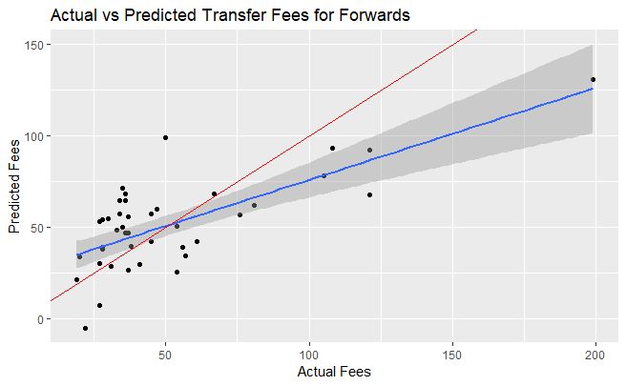  
*Figure 1: Actual vs Predicted Values for forwards’ transfer fees, from a linear regression*